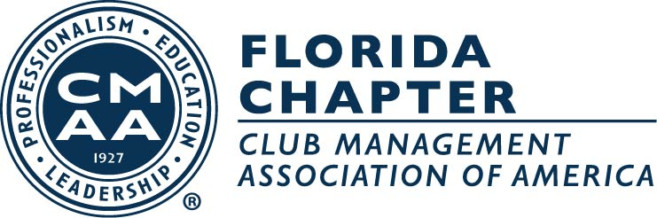

The Everglades Region Florida Chapter
CMAA 22nd Annual Charity Classic & Gala
October 20-21, 2019

The Everglades Region Florida Chapter CMAA
Would like to thank you for your donation for the upcoming Charity Classic.
Please complete this commitment form and provide the following information
NO LATER THAN October 4, 2019

Donor Name _______________________________________________________________

Contact Name______________________________________________________________

Address___________________________________________________________________

City _______________________________ State_______ Zip______________________

Phone ____________________________________ Fax ____________________________

E-mail ____________________________________________________________________

Item or Service Description __________________________________________________

__________________________________________________________________________
__________________________________________________________________________

Gift Certificate: Provided_________________ Need to Create _____________________

Restrictions:________________________________________________________________
___________________________________________________________________________

Can deliver_________ Will Mail_______________ Needs to Pick Up _________

Value of Donation ____________________________________________________

If you choose to mail, please send to:
CMAA Charity Classic
c/o LisaYorgey/The Eventful Company
247 NW 6th Place
Cape Coral, FL 33993
Ph: 239-204-8699

Or Scan and E-mail Form to: lisa@eventfulinc.com

