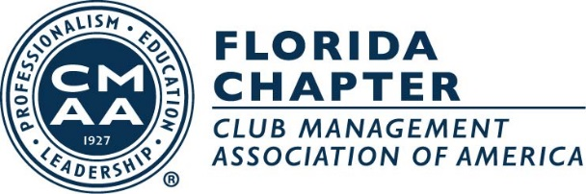

The Everglades Region of the Florida Chapter of the Club Managers Association of America is looking forward to celebrating our 22nd Anniversary of the Charity Classic Gala and Golf Tournament. Our organization has been helping and caring for kids in our communities since 1997. We have raised $2.1 million for children in Southwest Florida.

The 2019 Charity Classic will benefit Barbara’s Friends <http://www.leehealth.org/childrens-health/pediatric-support-programs/barbaras-friends-center.asp>, Youth Haven <http://www.youthhavenswfl.org/>, and a Hospitality School scholarship program at Florida Gulf Coast University <http://www.fgcu.edu/CoB/rhmbs/>.

In this year’s auction, which will be held October 20, 2019 at The Forest Country Club, we would like to include unique packages, trips, and experiences. We have included some suggestions below. Can we count on your Club to donate an item, or to reach out to some of your members who have access to experiences we can include, all of course to help meet our 2019 goal to support these fine organizations?

Below are a few examples of some unique auction items that would be very exciting and beneficial in raising money for Barbara’s Friends.

**CMAA Charity Classic Auction Package suggestions**

**Unique Experience**

* Drive a Race Car-Tap into club members who may own a race car or have access to a race car. What a thrill to drive a race car!
* Behind the Scenes Tour of NASA Space Center

**Party on the Beach**- Use someone’s beachfront property to plan a spectacular party for a group. This package could include a donation for property; caterer to donate the dinner; wine purveyor to donate the wine.

**Chef’s Dinners** Local chef dinners for 6 or 8 in auction winner’s home

**World renowned chef to prepare dinner for 6-8 in auction winner’s home**

(Note: If one of your club members is involved with the Winter Wine Festival, they may have these connections)

**Getaways**

Ski Trip to Utah or Colorado

Fall Tour/Bed and Breakfast Stays in Upper Northeast of Changing of the Leaves

Trips to Tropical Paradise spots

New York Trip with Broadway tickets

**Unique Sporting Experiences**

Box seats at professional sporting goods team: NFL, NBA, MLB, MLS

Meet and greet with owner of professional sporting goods team

Package to 2020 Masters or US Open Golf Tournaments

Please e-mail the attached donation forms to [lisa@eventfulinc.com](mailto:lisa@eventfulinc.com) and mail the donations to Lisa **at the address on the attached donation form.** You can contact Lisa Yorgey with any questions at 239-204-8699 or e-mail her at [lisa@eventfulinc.com](mailto:lisa@eventfulinc.com)

Thanks so much for helping us make children’s dreams come true.

Sincerely,

Donald Sawin

Director of Sales

The Classics Country Club